Incident No: INC4643444

Issue: SolManID# 7000050171 NAFTA:cannot reverse good issue (OSS Note: 265589/2026)

Analysis: There was a physical shortage of 8 PCA for delivery 149608268, which led the user to request a PGI reversal. However, the goods receipt had already been posted, and because handling units (HUs) were involved, reversing the GR was not possible.

Resolution: A new delivery 149653758 was created via transfer posting for the missing 8 PCA, and the stock was moved back to the original storage location UXHR / HU05. With this correction, the issue was resolved and the ticket has been closed.

Original PO:
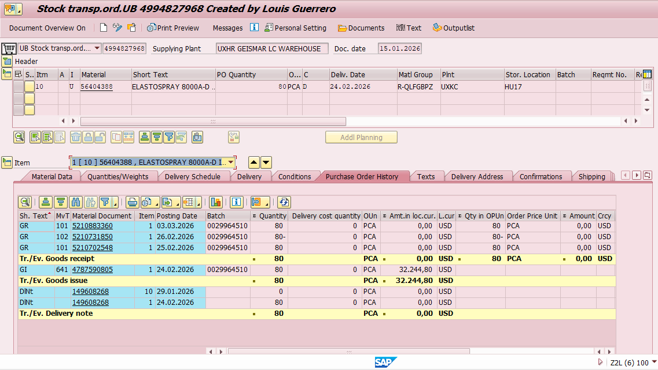

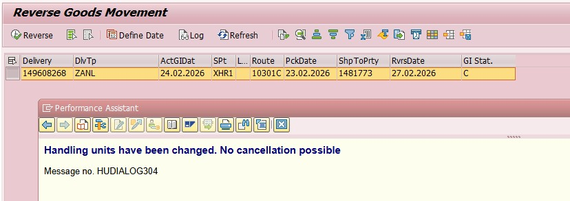
TP Delivery: 